John and Rhona’s October Walk – 1115 on Sunday 17th November 2019
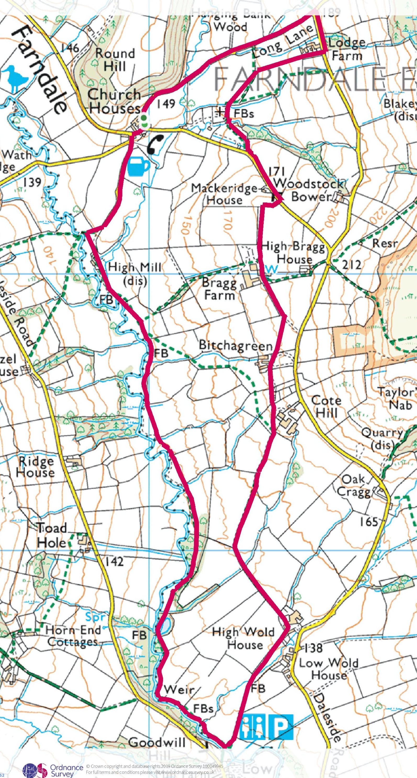
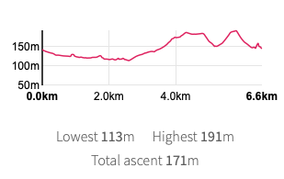
This is a gentle circular walk involving no fords. It is approximately 6.6km [4 miles or so]. It crosses fields for the first half and the second half is along the river bank pathway which is mostly gravelled. There will be no daffodils.
Unfortunately there are a number of stiles on the first part that would be very awkward for dogs – they’re sort of stones sticking out of high stone walls [the stiles, not the dogs] – so not an overly dog-friendly walk, sorry.
Meet in the carpark of the Feversham Arms in Church Houses, Farndale. We will also be eating in the pub. As a bonus there are toilets at the halfway mark [not Portaloos], in Low Mill.
We are expected in the Feversham Arms at 1430, for those not coming on the walk. Menu options are below.
Could you please send your choices to Rhona by the 11th November, on rhona.sutherland@btinternet.com

STARTERS
Seasonal Soup served with a warm roll - £3.95
Battered Mushrooms served with garlic dip & salad - £4.60
Black Pudding & Poached Egg served on a bed of salad - £5.25
Prawn & Salmon Cocktail served with marie-rose sauce [GF] - £5.95
Pate & Warm Toast - £4.25
MAIN COURSE MENU
Roast Beef Sunday Lunch - £9.95
10oz Sirloin Steak* served with onion rings, mushrooms & salad - £16.95
Home Cooked Gammon* served with two eggs or pineapple & salad - £11.95
[*additional Sauces - £3.35 Dianne Sauce - Peppercorn Sauce - Stilton Sauce]
Slow Cooked Belly Pork served on a bed of black pudding mash & vegetables - £10.95
Homemade Game Pie - £10.25
Homemade Steak, Ale & Mushroom Pie - £10.25
Cumberland Sausage on bed of mashed potato with gravy & vegetables - £9.95
Chicken Parmesan Or Hot Shot Chicken Parmesan served with salad - £10.25
Sweet & Sour Battered Chicken served with rice - £10.25
Homemade Beef Lasagne served with garlic bread & salad - £9.95
All the above meals are served with homemade chips & vegetables unless stated otherwise. Mashed potato is available if you prefer.
Wholetail Breaded Scampi served with chips & salad - £11.25
Large Freshly Battered Cod served with chips & mushy peas - £11.95
Smoked Haddock Fishcakes served with chips & salad - £9.15
VEGETARIAN DISHES
Homemade Vegetable Lasagne served with garlic bread & salad - £9.25
Sweet & Sour Vegetables served with rice - £9.25
Large Yorkshire Pudding filled with vegetables - £5.95
VEGAN DISHES
Three Bean Chilli served with rice - £9.95
Spinach, Sweet Potato & Butter Bean Stew - £9.95
DESSERTS £4.50 each Please ask to see the dessert board

