Oswaldkirk Village Walk – Sunday 27th February 2022

There are 2 walks (a Long and a Short walk) organised by David and Gaynor Badham both walks starting from Coxwold Village Hall car park where you should leave your cars.

The LONG Walk is 5 miles starting at 11am from the car park and is scheduled to get back to the car park by 2pm. There is only 1 stile. This walk will be led by David and has been chosen to suite walkers able to cover this distance in the time frame of 3hrs which will include a short refreshment/rest stop (bring what you need). In the event of inclement weather or fatigue this walk can be shortened at the crossover point to return to the car park (cuts 1 mile and approx.45mins off the 5mile walk time – a straight route back to Coxwold along an old railway track, now a footpath.

The SHORT walk is 2 miles starting at 12.30pm from the car park and is scheduled to get back to the car park by 2pm allowing for stops to take in the views. There are no stiles. This walk will be led by Gaynor and is a more leisurely walk over a shorter distance chosen to suite walkers accustomed to a more leisurely pace. You may wish to bring some light refreshment.

For both walks stout footwear with good treads is advisable to withstand the rigours of winter weather as well as clothing suitable for this time of year. Maps of both walks are attached to the email.

Both walks are suitable for dogs but you are requested to keep them on a lead when on paths across farming land. At the time of writing this description there are no cattle on either of the walk paths.

For those who wish, arrangements have been to eat at The Fauconberg Arms in Coxwold at 2.15pm and the menu choices are below. You will need to give us your orders by Monday 21st February so table bookings can be made in good time as it is a popular eating venue on Sundays. Please contact us by phone on 01439 787046 or by email to davidbadham@hotmail.com with your dining requirements and whether you are walking on the LONG or SHORT walk or those not walking but who may wish to JUST EAT with us.
EXAMPLE
Bill and Jean both walking – Bill SHORT walk but Jean LONG walk. Both eating as follows –
Bill – S1 and M2 pork
Jean – No starter but M3 and maybe dessert

The Fauconberg’s Sunday Lunch Menu - Be there for 2.15pm. Parking at the premises.

Covid Face Masks required when entering and movement within the premises.
Starters: - as priced individually
S1- Soup of the day with homemade crusty roll & butter £6.00
S2- Chicken liver and brandy pate served with chutney and toast £6.00
S3- Goat’s cheese and red onion tart served with salad and balsamic glaze £7.00

Mains: - as priced individually
M1- Locally sourced roast beef, pork, or chicken breast. All served with Sunday vegetables and Yorkshire puddings £15.00
M2- Lightly beer battered haddock, hand cut chips, peas, tartare sauce and lemon £14.95
M3- Fauconberg steak and ale pie, new potatoes or hand cut chips, peas and gravy £14.95
M4- Braised local beef cheeks in red wine, creamy mash, roasted root vegetables and red wine sauce. £18.00 M5- Vegetable Curry and rice. £15.00
Desserts: Order on the day from the desserts board as available.

Please let us know who is walking on Long Walk or Short Walk and who is eating with your course choices by email to davidbadham@hotmail.com or by telephone on 01439 787046 by Friday 20th March. We do hope you can join us. David and Gaynor Badham

Oswaldkirk Village Walk - Sunday 27th February 2022 WALK MAPS

LONG WALK - 5 Miles
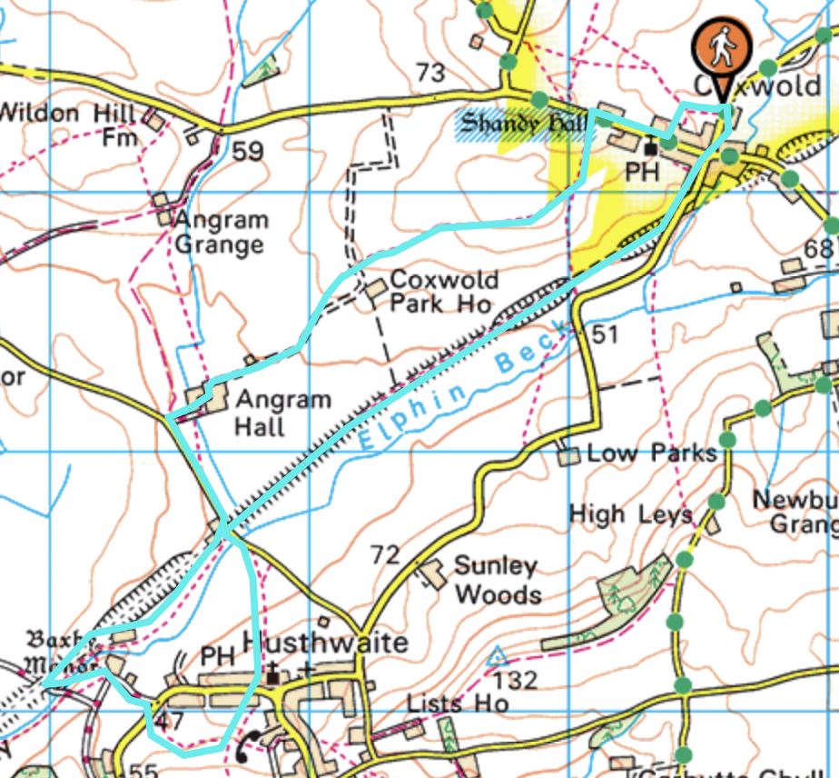

SHORT WALK – 2 Miles
